**5 Reasons Why You Should Sell Your Old Hardware To Recycle Pro**

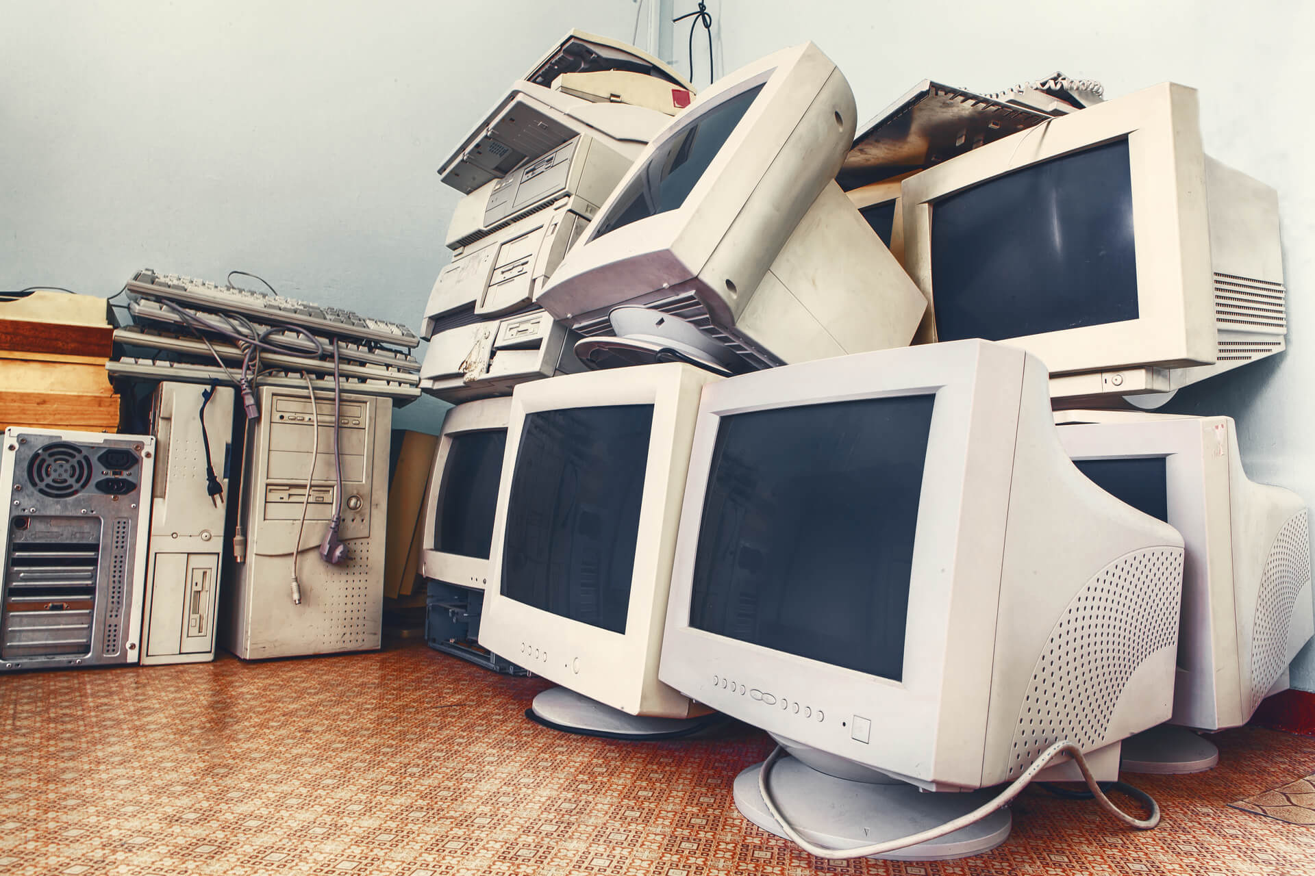

All electronics will eventually outlive their usefulness and be replaced by newer generations. We talk a lot about the sustainability of recycling old devices at Recycle Pro.

Why not help yourself and the environment by selling your old hardware to a reputable recycling company?

Here are five reasons why you should contact Recycle Pro to turn your garbage into treasure if you own a business and have a lot of obsolete gadgets.

**Easy Cash for Your Business**

We at Recycle Pro believe in providing the most competitive prices for our customers' old hardware or telephone equipment. However, several businesses refuse to take advantage of our offer because they assume the process will be time-consuming and difficult.

Our team will discuss what you want to sell, what we accept, and provide you with a rapid price. The transaction is quick once you accept our quote, and your company walks away with extra money to spend in its future.

However, keep in mind that the value of old gadgets depreciates over time. So, in order to get the best ROI, it's always in your company's best advantage to sell obsolete gear as quickly as feasible.

**We Purchase a Variety of Antique Hardware**

Businesses sometimes keep obsolete hardware because they assume that no one can benefit from it because it is old. Most retired electronics have worth to our recycling organisation, and we are always willing to buy devices from the most popular manufacturers.

RetirePC accepts Apple, Cisco, Dell, Samsung, and Blackberry, to name a few. Contact us to see whether we can help you make money off of your old equipment, regardless of what hardware brand your company used.

**You Save Time by Selling Old Electronics**

You aren't saving your firm any time or money if you keep outdated gadgets and mix in the use of old technology with your new investments.

As it struggles to keep up with your workload, out-of-date technology slows down and develops malfunctions. When this happens, your productivity suffers, time is spent, and business profits are lost.

Selling your old computer gear not only encourages your organisation to invest in and use new technology, but it also helps fund the purchase of that technology.

Technology's ageing is a natural part of life. Recycle Pro just assists you in fulfilling your responsibilities.

**Security of Data**

One of the most compelling reasons to sell obsolete technology is to ensure the protection of your data. Hackers and untrustworthy personnel will be attracted to old technology that has been left lying around or in storage.

Let us help you retrieve your data, acquire your old gear, and use our data destruction method to protect your company's secrets if you aren't utilising it.

**Ecological Responsibility**

Most companies are aware that discarding obsolete equipment is bad for the environment. Allow Recycle Pro to assist you in taking your environmental initiatives to the next level. By selling your old gear to Recycle Pro, you can reduce your company's carbon footprint while also making some quick cash.

Allow us to assist you in achieving the ultimate win-win situation.

**With Recycle Pro, you can get money for your old hardware.**

[Recycle Pro](https://www.recyclepro.co.uk/) is ready to pay you cash on the spot for your old gadgets, no matter how much or how little you have to offer. We are a recognised electronic recycling firm that can assist you in getting the most money for your old computer hardware or used telephone equipment.

We make it simple to sell your assets, allowing you to make a smooth transition into freeing up space at your company.

To organise a pick-up or delivery of your old gear, contact us immediately.